**Career:** Software Engineering

**Subject:** Advanced Web Programming

**Teacher Name:** Edison Lascano

**Requirements Specification**

**Group 4**

**2022/2023**

# Document file

|  |  |  |  |
| --- | --- | --- | --- |
| Date | Revision | Description | Authors |
| /08/2022 | 1.0 | Introduction and initial requirements. |  |
| 08/19/2021 | 1.1 | Interface requirements and system functions. |  |
| 08/21/2021 | 1.2 | System attributes and other requirements. |  |
|  |  |  |  |

# 

# 

# 

# 

# **Contents**

**Document Sheet**  **2**

**Content**  **3**

**Introduction**  **4**

1.1 Purpose  4

1.2 Areas of the system  4

1.3 Definitions, acronyms and abbreviations.  5

1.4 References  6

1.5 Overview of the document.  6

**Overview**  **7**

2.1 Product perspective  7

2.2 Product functionality  7

2.3 User characteristics  8

2.4 Restrictions  9

2.5 Assumptions and dependencies  9

2.6 Evolution of the system  9

**3. Specific requirements**  **9**

3.1 External interfaces  10

3.1.1 Graphical user interface  10

3.1.2 Hardware interface  13

3.1.3 Software interface  14

3.1.4 Communication interface  14

3.2 Functions  14

3.2.1 Functional requirement 1  14

3.2.2 Functional requirement 2  16

3.2.3 Functional requirement 3  17

# **Introduction**

This document will describe in depth the Specification of the software requirements of the system to be built, which will serve as information support for the implementation of the software, analyzing and understanding the requirements and requirements that were proposed for this project. In addition, aspects such as: the attributes of the system, the actors and those involved, its user interfaces, among others, will be described in detail.

## **1.1 Purpose**

* Allow establishing agreements for the design and coding of the software to solve the problem of drug registration in a pharmacy.
* The requirements and requirements are directed to the developers and designers of the software in order to understand exactly the final objective of the project.

## **1.2 System scopes**

* Identification of the software product: A "Medication registration system" will be developed, this system has the purpose of solving the correct registration of medicines of a popular pharmacy.
* System goals:
* Allow medication management.
* Allow proper registration of different medications.
* Allow to carry out a crud of one or several medications.
* Issue medication reports.

## **1.3 Definitions, acronyms and abbreviations.**

**Definitions.**

**Database.- It** is a set of information organized and stored in a computer or in a virtual space (cloud) from which the data saved for use can be retrieved. The stored information is structured in tables, in rows and columns, which in turn are made up of fields or attributes and data that define the field.

**Framework.-** Structure (template) or standardized set of criteria that facilitates the development of software, which is complemented to solve the problem.

**FrontEnd.-** Part of an application that interacts with users, also known as “the client side”. It is everything that we see on the screen when we access a website.

**BackEnd.-** Part of an application that interacts with the server also known as "the server side". It is the part where the data is processed between the user, the application and a database.

**Connection.** - It is defined as a link or communication that unites one thing with another, and these have similar characteristics.

**Interface.-** Refers to the physical connection established between the user and the system. This connection occurs through objects, icons and graphic elements.

**Website.-** It is a set of web pages referring to a particular topic, the same one that serves as an interaction between the human and the machine in the realization of specific requests within it.

**Login.-** Data entry (administrator and password) to access a system, when they are registered.

**Acronyms:**

**DBMS.-** Acronym used to refer to the Database Management System, which is a collection of software aimed at the creation, administration and implementation of a database.

**BDD** .- Acronym used to refer to Database.

**ERS.-** Acronym used to refer to System Requirements Specification.

**URL.-** For its acronym in English Uniform Resource Locator, which in Spanish means uniform resource locator, is the unique address that is assigned to the various Internet resources such as: websites, blogs, etc.

**GUI.-** For its acronym in English Graphic User Interface, refers to the entire graphical environment (images, text, buttons, etc.) of the software.

**Abbreviations:**

**Engineer** Engineer.

**SW.** Software.

## **1.4 References**

|  |  |  |  |  |
| --- | --- | --- | --- | --- |
| **Reference** | **Title** | **Date** | **Route** | **Author** |
|  |  |  |  |  |
|  |  |  |  |  |

## **1.5 Overview of the document.**

The requirements specification will contain the following:

* **Introduction:** This section contains a detailed description of the objectives of the requirements specification and of our project.
* **General Description:** A general vision of the system to be developed is described, in addition to the types of users that will exist in it and its characteristics, finally the limitations that the final product will have are detailed.
* **Specific Requirements:** At this point, all the user requirements that you want to see in the system to be developed are listed, for which the "IEEE 830 Standard" has been used.

# **General description**

## **2.1 Product perspective**

The system to be developed is independent of other products, in the course of our career we have not seen a similar system firsthand, this Software will have an adaptable or responsive web design, both images and text, on each page within the website.

## **2.2 Product functionality**

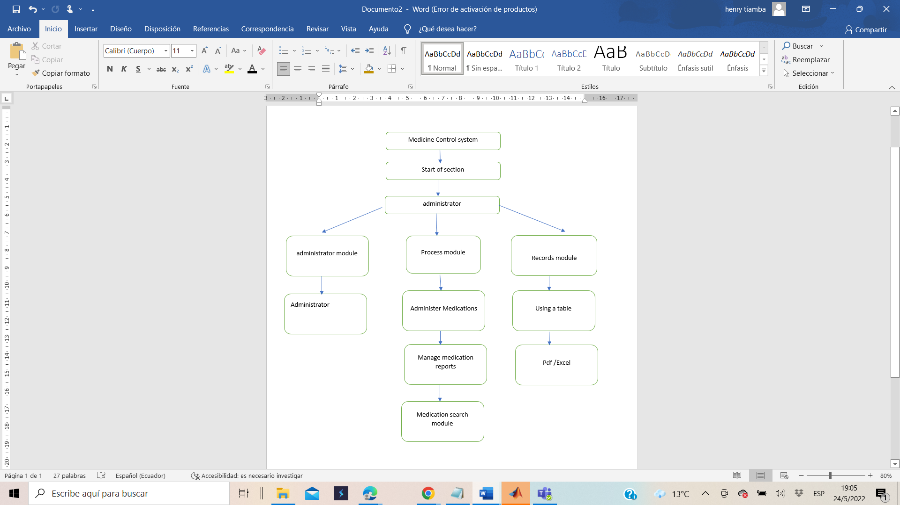

## **2.3 User characteristics**

|  |  |
| --- | --- |
| Type of user | Administrator |
| Training | Intermediate computer knowledge. |
| Skills | Management of computers and schedule management systems. |
| Exercise | Manage medication and pharmacy data and view reports. |

## **2.4 Restrictions**

This system will be developed in HTML, a hypertext markup language, in addition to the implementation of CSS that will provide the design and style of the frontend, JavaScript to carry out all the processes of the system, PHP will establish the connection to the MongoDB atlas database. ..

## **2.5 Assumptions and dependencies**

None.

## **2.6 Evolution of the system**

Implementation of a distributed database to improve information processing, in addition to carrying out information security protocols and encrypting data traffic between a web browser and a SSL (Secure Sockets Layer) website.

# **3. Specific requirements**

R1. Check the authentication of registered users (administrator,).

R2. Allow the realization of a Crud of the medicines

R3.Organize medications according to their characteristics.

R4. Allow the entry of medication data.

R5. Allow administrator recovery of your username and password).

R6. Generate reports of drugs in stock.

## **3.1 External interfaces**

### **3.1.1 Graphical user interface**

The graphical user interface presented below will help the end user in interactions with the system. These include:

* Buttons
* drop down menus
* Error or confirmation messages
* popup windows
* Informative messages
* Form for entering the system.
* Form for the realization of the respective crud.
* Medication reports.

A mock-up of the processes is shown below:

* Log in
* Enter medications
* Medication data entry
* Medication Modification Option

**Log in**

The following mock-up shows how the user interface will look when you try to enter the system, for which you must have been registered.

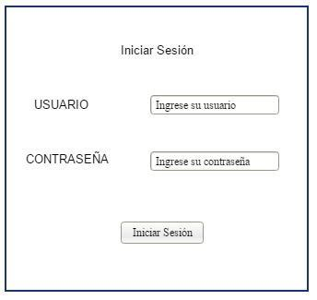

If the username or password is wrong then the system will display the following message.

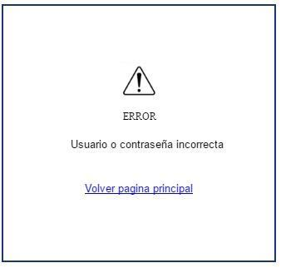

**Enter medications**

The following model will show the interface to the administrator for the entry of medications.

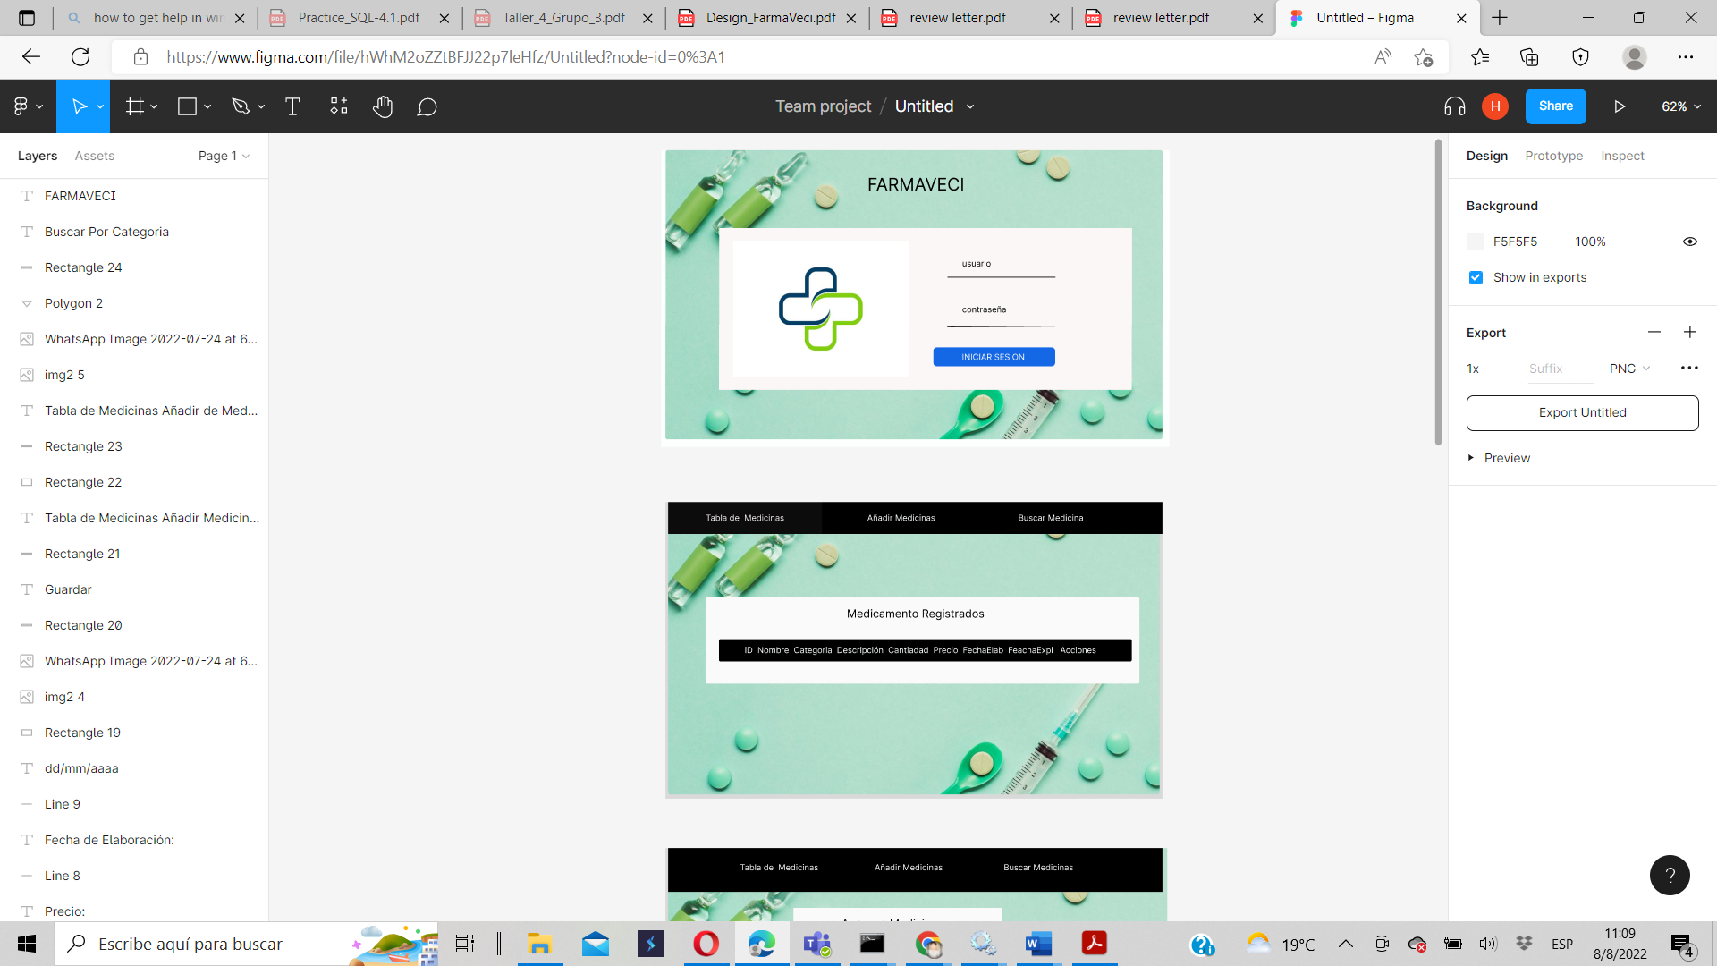

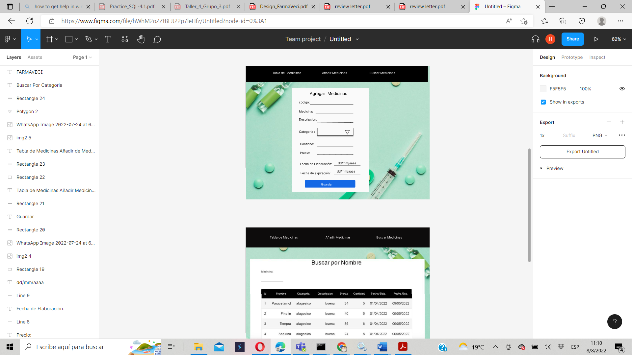

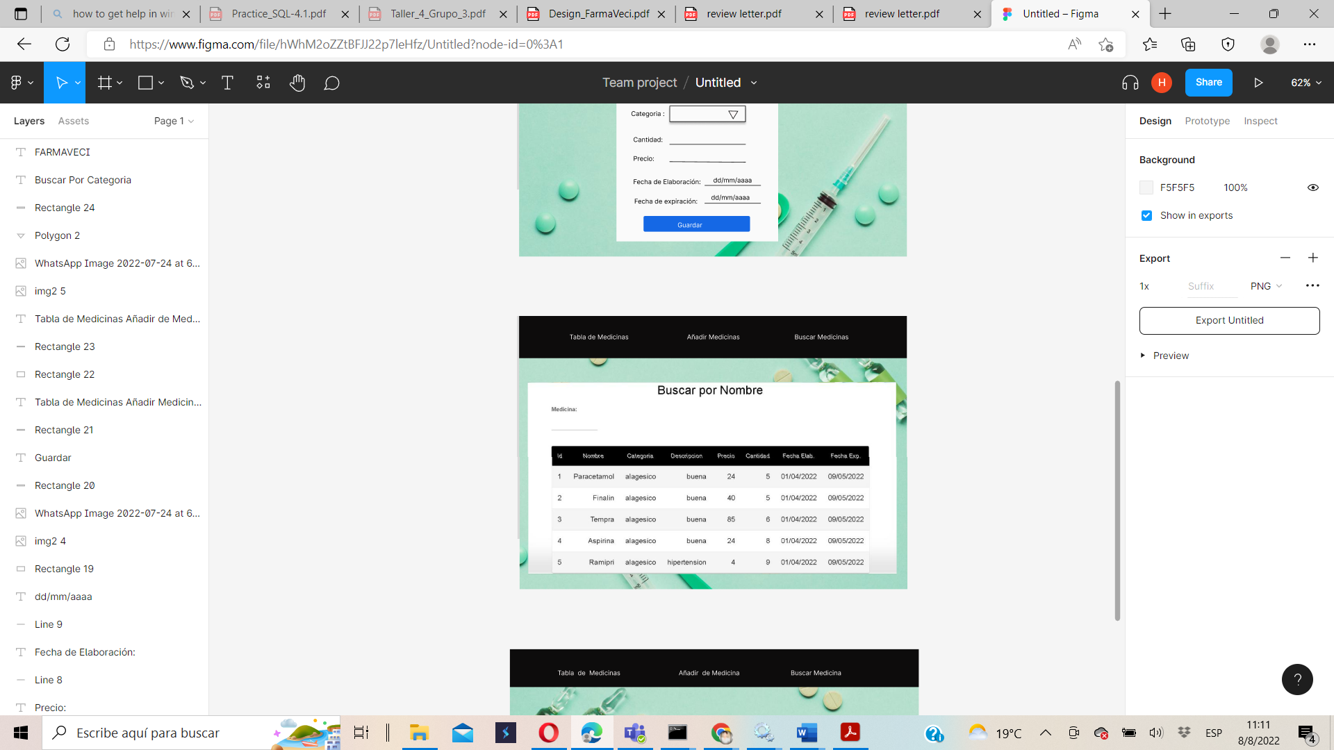

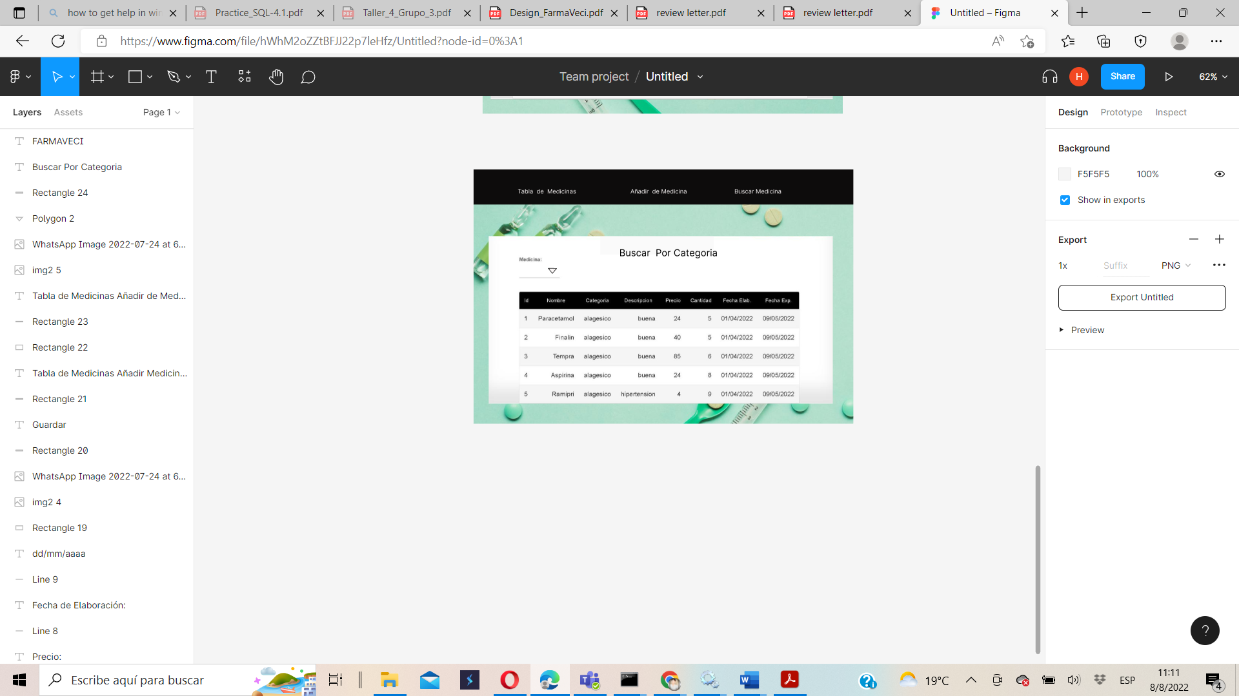

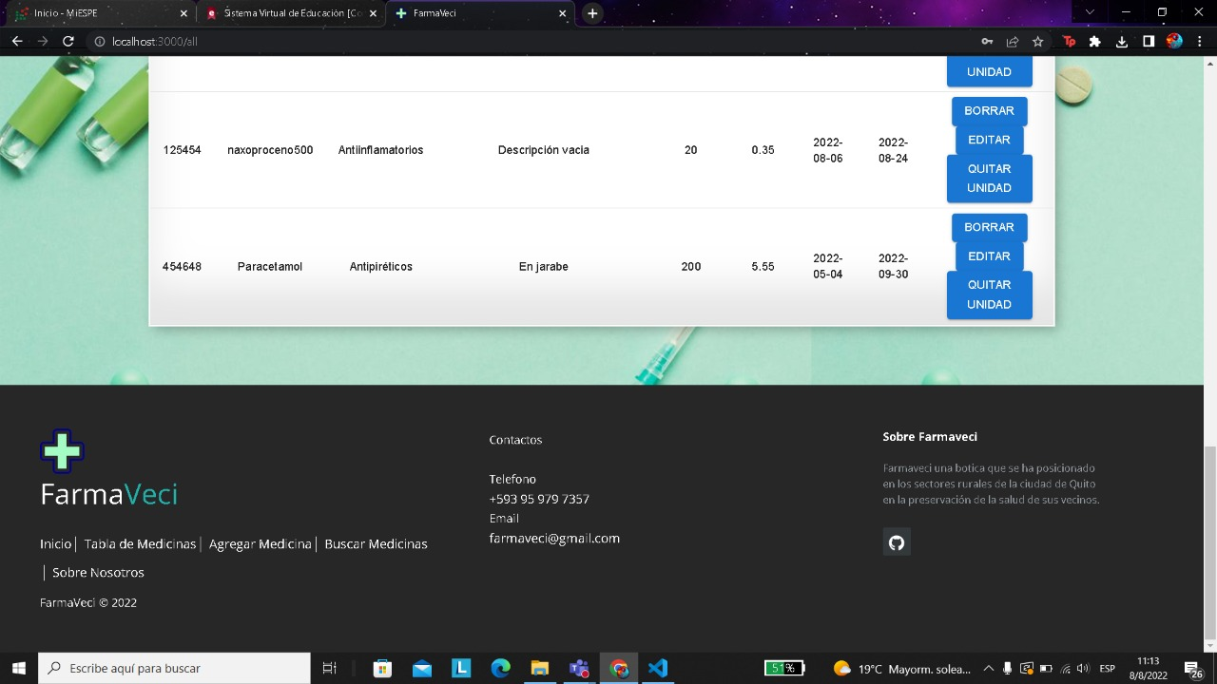

In the table you will find the medications entered

### **3.1.2 Hardware interface**

When we talk about hardware interface we refer to the set of tools or physical devices that allows us to enter and receive data from a given software. In our case, the devices that will be useful in this process are:

**Monitor (screen).-** The web application will display the GUI and software information through the screen.

**Keyboard.-** The web application will have interactions with the keyboard, which will be very important when entering data in the software.

**Mouse.-** The web application will have interactions with the buttons and movements of the mouse, which will have to communicate with the menu and buttons of the software.

**Printer.-** This device will allow us to have physically (printed on sheets of paper) the reports and schedules generated by the software.

### **3.1.3 Software interface**

The software interface that our web application will have will be carried out thanks to the implementation of:

* Bootstraps Framework.- used in the front-end (interface) for the development of web applications or sites, with a design that adapts to the screen of the device that the user is using, maintaining the responsive or adaptive web design.

### **3.1.4 Communication interface**

The communication interface that will be used between the MongoDB Atlas database server and the web application will be developed in HTML with a framework, in this case we will use Bootstrap.

## **3.2 Functions**

### **3.2.1 Functional requirement 1**

|  |  |
| --- | --- |
| requirement number | R1 |
| Requirement Name | Check the authentication of registered users (administrator). |
| Guy | * ~~Requirement~~ |
| Requirement Source | DB: |
| Requirement Priority | * ~~High-Essential~~ * Average-Desired * Low-Optional |

**Introduction:**

The system must perform the validation and allow the entry of data (username, password) of the user, as well as the authentication of the user's registration. These will serve to access the specific functions of the system.

**Tickets:**

User password

**Processes:**

The system will request the identification data to access it. The form will be presented once you enter the website, without the need for an extra action. It will ask for the user's username and password, it verifies that it complies with the imposed validations (without spaces) and its existence within the database. If these data do not exist, the system sends an error message and if there is none, a user must be created

**Departures:**

Error message if you have not filled in all the fields.

Error message in case of entering wrong username.

Error message in case of entering the wrong password.

Error message if these data do not exist in the database.

### **3.2.2 Functional requirement 2**

|  |  |
| --- | --- |
| requirement number | R2 |
| Requirement Name | Allow the realization of the Crud of medicines |
| Guy | * ~~Requirement~~ |
| Requirement Source | BDD: data entered by the administrator. |
| Requirement Priority | * ~~High-Essential~~ * Average-Desired * Low-Optional |

**Introduction**

The system must allow creating (data entry), modifying and deleting, searching,

**Tickets**

The entries for the entry of medicines will be: id, name, description, Quality, Price.

**processes**

In order to comply with this requirement, the system must have verified that the user is of the administrator type. A button will be displayed where it says add medication, where the fields to be filled in once will be displayed, filled out, that information will be sent to the database, the administrator will be able to verify the data in a table by clicking on show

**Departures**

Outputs are addressed to: administrator

Warning message: when creating, modifying or deleting a medication.

Error message: in the event that the fields are empty or do not comply with the format established in the create, modify and delete medications form.

### **3.2.3 Functional requirement 3**

|  |  |
| --- | --- |
| requirement number | R3 |
| Requirement Name | Perform the search for available drugs and in stock. |
| Guy | * ~~Requirement~~ |
| Requirement Source | BDD: Medication Table |
| Requirement Priority | * ~~High-Essential~~ * Average-Desired * Low-Optional |

**Introduction**

The system must allow the search of any medication entered by the administrator.

**Tickets**

the entries for the drug search will be the drug id

**processes**

In order to comply with this process, the administrator must click on the search button, where the system will display a field for the entry of the search data by the administrator, which in this case will be the drug ID

**Departures**

Outputs are addressed to: Administrator..

Error message: in the event that the fields are empty or do not comply with the format established in the generator form for the drug search

### **3.2.4 Functional requirement 4**

|  |  |
| --- | --- |
| requirement number | R4 |
| Requirement Name | Allow the entry of medication data . |
| Guy | * ~~Requirement~~ |
| Requirement Source | BDD: Drug Crud Table |
| Requirement Priority | * ~~High-Essential~~ * Average-Desired * Low-Optional |

**Introduction**

The system must allow the entry of any medication by the administrator.

**Tickets**

The tickets will be your name, id, category, description, price, quantity, date of production and expiration date.

**processes**

In order to comply with this process, the administrator must click on the save medicine button, where the system will connect to the database and add the medicine dictated by the administrator.

**Departures**

Outputs are addressed to: Administrator..

The system will display a table with all the medicines added to the database as long as they are added successfully.

### **3.2.4 Functional requirement 5**

|  |  |
| --- | --- |
| requirement number | R5 |
| Requirement Name | Allow administrator recovery of your username and password . |
| Guy | * ~~Requirement~~ |
| Requirement Source | DB: System Login |
| Requirement Priority | * High-Essential * ~~Average-Desired~~ * Low-Optional |

**Introduction**

The system must allow the recovery of the username and password by the administrator.

**Tickets**

The inputs will be your username and a number belonging to your id as verification.

**processes**

In order to comply with this process, the administrator must click on the recover password link with which, following the steps, you will be able to view your username and password to access the system.

**Departures**

Outputs are addressed to: Administrator..

The system will display a view where the username and password of the respective administrator will be.

### **3.2.4 Functional requirement 6**

|  |  |
| --- | --- |
| requirement number | R6 |
| Requirement Name | Generate reports of medicines in stock. |
| Guy | * ~~Requirement~~ |
| Requirement Source | BDD: System Crud |
| Requirement Priority | * ~~High-Essential~~ * Average-Desired * Low-Optional |

**Introduction**

The system must allow the display of a table with the drugs registered in the database for later modification.

**Tickets**

There are no entries as the system will simply give the administrator a view.

**processes**

In order to comply with this process, the administrator must wait for the connection to the database and a table will be displayed showing all the medicines in stock.

**Departures**

Outputs are addressed to: Administrator..

The system will display a view where all the medicines available in the pharmacy will be displayed.